DATABASE SYSTEMS ENGINEERING AND DISTRIBUTED BACKEND DEVELOPMENT

Sec:- 3

Name:- Sai Sowseelya Vedula
Roll no:- 2520030260

2- WHERE, ORDER BY, GROUP BY, HAVING & AGGREGATE FUNCTIONS

Input
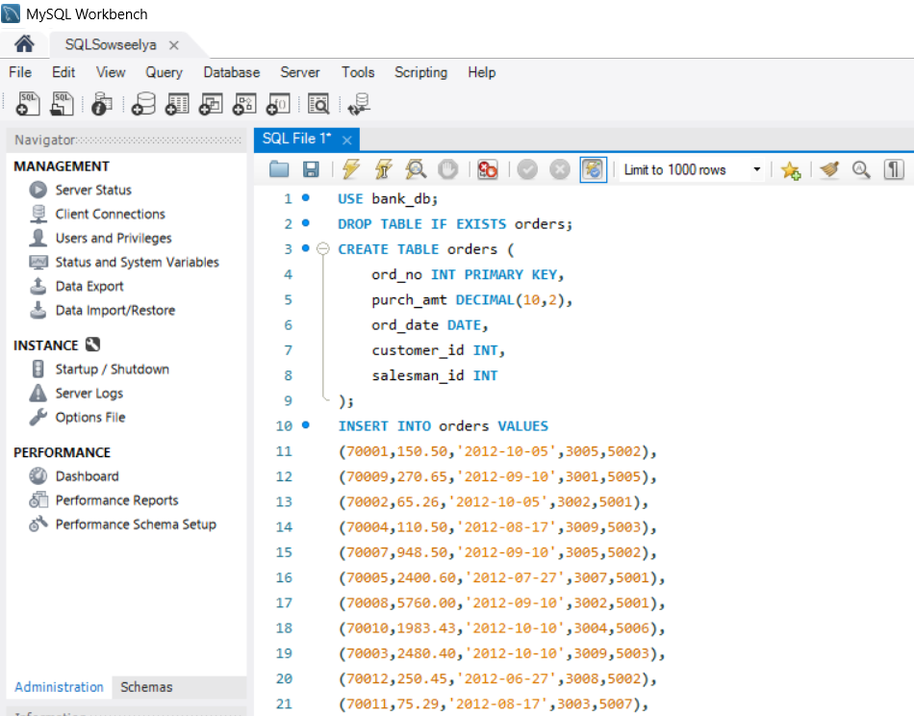
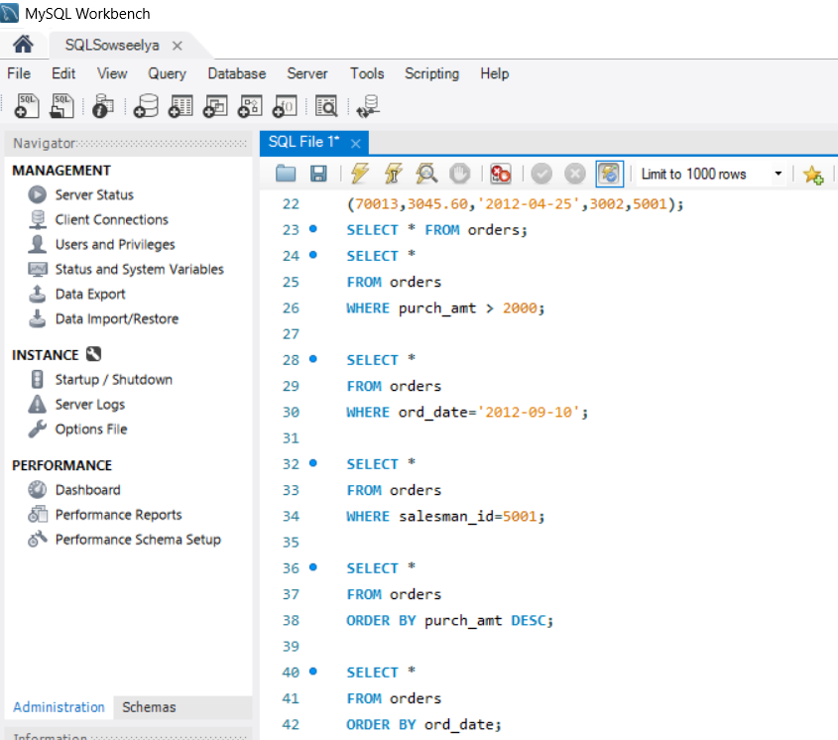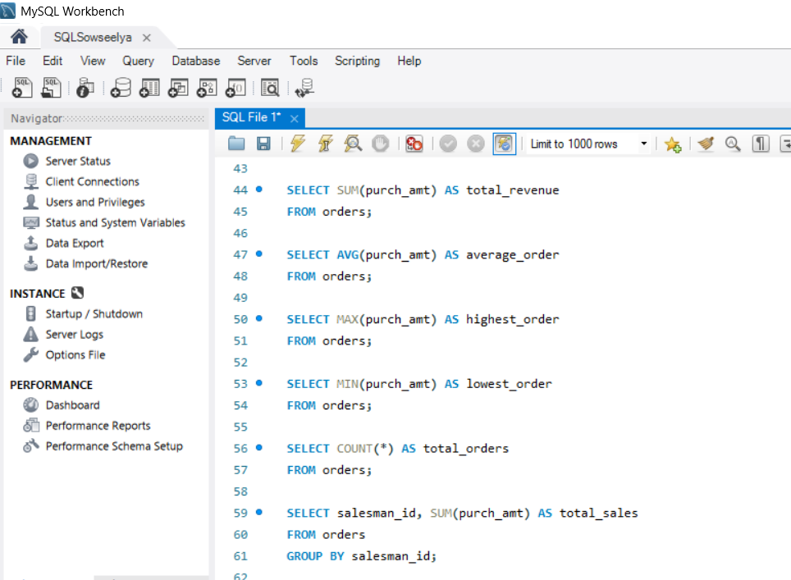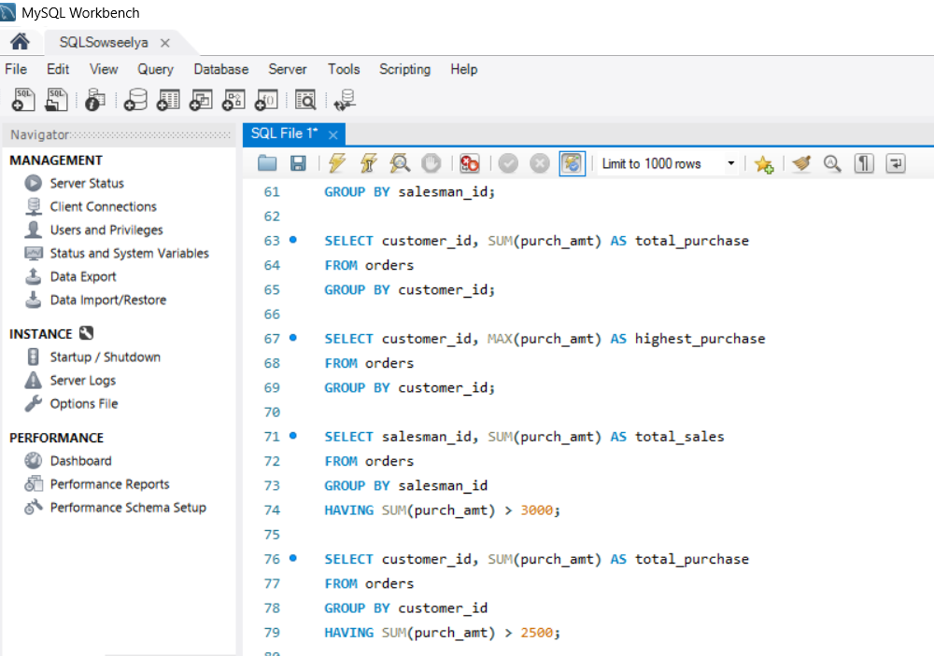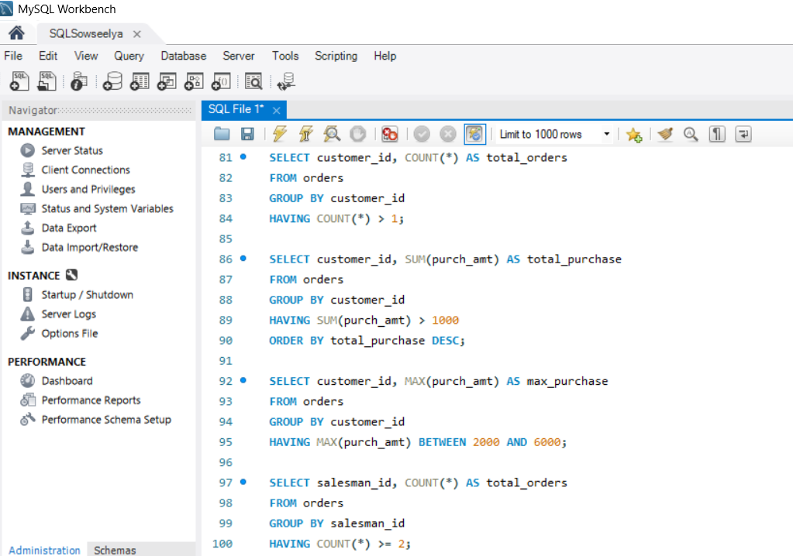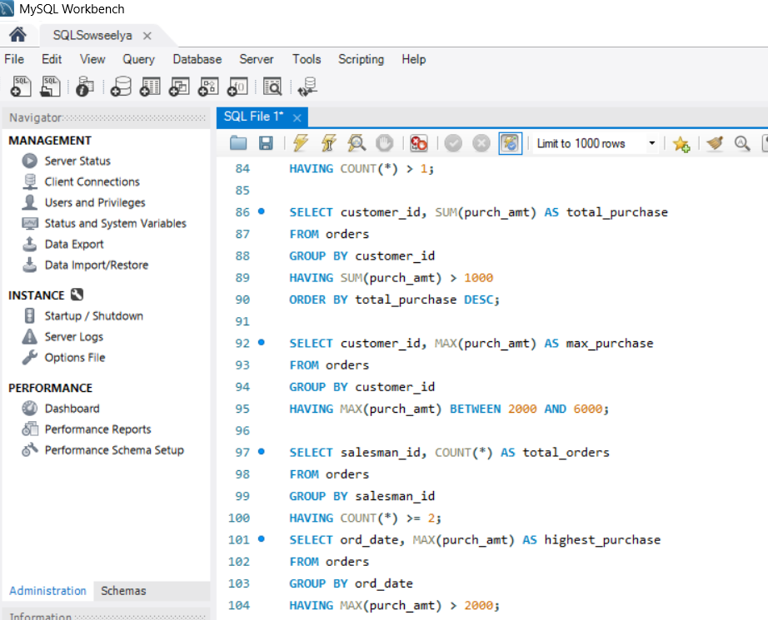

Action Output
